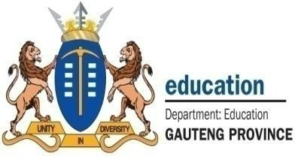


NPO
No: 001041

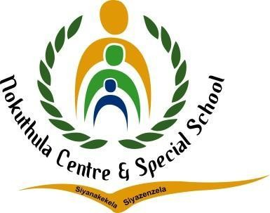
ENGLISH LESSON PLAN

TEL: (011) 444 6443
FAX: (011) 444 6955/2625944
E-MAIL: nokuthulasmh@mweb.co.za

Subject: English |  | Grade: 2 |  | Term: 3 |  |  | Week: 6-7
TOPIC: People who help us in our community. | Content:  - Listening and Speaking  - Phonological/Phonemic Awareness/Phonics  - Emergent Reading  - Shared Reading  - Handwriting and Writing |  | Time allocation:  2 hours daily |  |  | Date started: |  | Date completed:
Prior content knowledge:  - Learners should have prior knowledge about the different people in our communities who offer different services that in return help the community.  - Learners interact with the people who help the community e.g. at schools, hospitals etc. |  | Lesson objectives: The learners must be able to:  - Identify different people who help us with different services in our communities.  - State the services provided by the people in our communities.  - Explain how the services work.  - Explain how the services help or benefit the community. |  |  | Vocabulary/ important words:  - Teacher  - Social worker  - Doctor  - Police  - Nurse  - Taxi driver |  |  | Teaching strategies:  - Learner centered method  - Question and answer session  - Demonstrating  - Collaboration


Resources:  - Chalkboard  - Chart  - Worksheet  - Big storybook  - Projector | TEACHER’S ACTIVITIES  Listening and Speaking  - I will introduce the lesson by playing a video about the different people who offer important services in our communities.  - I will ask learners to explain how they benefit from the services offered by those people in our communities. | LEARNER’S ACTIVITIES  - Learners will watch the video about different people who offer important services in our communities.  - Learners actively participate in the class discussions and ask clarity seeking questions. | Assessment goal: Assessment strategy: Informal  X  Formal    Assessment tool:  - Rubric
 | Phonemic Awareness
 | - Recognize specific identified sight words from the lesson topic.  - Build and blend words with the taught word families.  - Recognize and name the letters of the alphabet. | - Learners actively listen to the ABC songs and try to identify letters of their own names.  - Learners attempt to answer given activities.
 | Reading  - Read a story about one of the roles played by one of the people who help in the community e.g. Read a story about a nurse and how he/she helps the community. | - Learners read Big Book stories with the teacher. Predict what will happen next in the story using pictorial cues.

 | Handwriting and Writing  - Task learners to trace the names and the occupations of the people who help us in our communities.  - Give learners patterns (rounded, pointed, vertical lines), letters and words to trace. | - Learners will trace the names and the occupations of the people who help us in our communities.  - Learners trace patterns, letters and words.
Differentiation (Enrichment opportunities/ addressing barriers) |  |  | Practical task
- Group 1: Learners will be given an activity to color the pictures of a certain profession/career e.g. Doctor.  - Group 2: learners will be given an activity to match the pictures of different people and the occupations they work in.  - Group 3: Learners will be given an activity to draw a picture of a profession/career that they like. |  |  | Learners will draw and color different pictures of the careers of their choice.
Teacher reflection: |  |  | Name of Teacher:  JS Zimba  LM Vinger
HOD Input: |  |  | Name of HOD:

